**Task 1**

Description:

Creating a simple calculator in C programming using the

If selection statement,

switch Multiple selection statement,

while iteration Statement,

Counter Control iteration,

This program takes an arithmetic operator +, -, *, / and two operands from the user. Then, it performs the calculation on the two operands depending upon the operator entered by the user.

The * operator entered by the user is stored in op. And, the two operands, 1.5 and 4.5 are stored in first and second respectively.

Since the operator * matches case '*':, the control of the program jumps to

printf("%.1lf * %.1lf = %.1lf", first, second, first * second);

This statement calculates the product and displays it on the screen.

To make our output look cleaner, we have simply limited the output to one decimal place using the code %.1lf.

Finally, the break; statement ends the switch statement

**Code:**

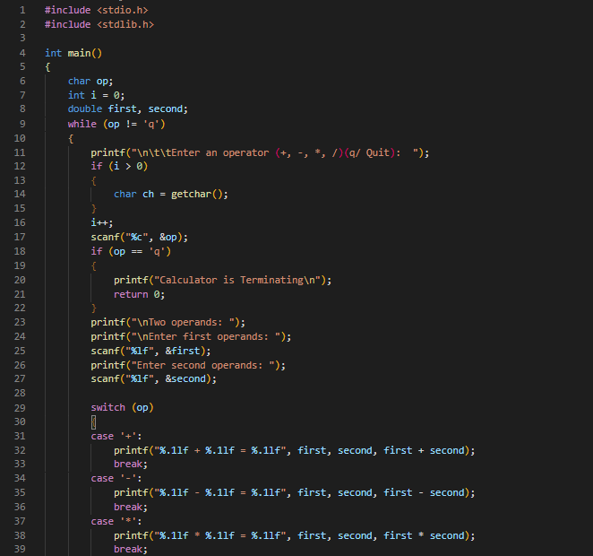

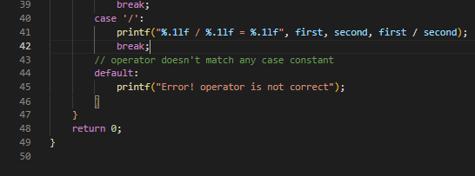

**Output:**

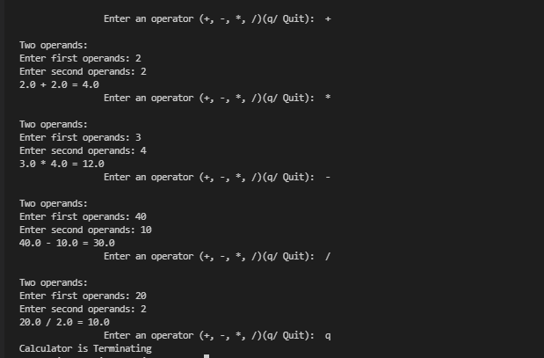

**Task 2**

**Number Converter:**

Description:

The topics we covered in this program is:

Control Structure,

If selection statement,

If else... selection statement,

Nested loop Counter statement

switch Multiple selection statement,

while iteration Statement,

Counter Control iteration,

For iteration statement,

Here is a program for numbers conversion. This program can convert Binary number, decimal number and hexadecimal number to each other respectively.

By entering choice, you can get choice for number conversion.

If user can choice 1, it will convert binary to decimal

For choice 1, it will take binary number and it will output will be in decimal number.

If user can choice 2, it will convert binary to hexa-decimal

For choice 2, it will take binary number and it will output will be in hexa-decimal number.

If user can choice 3, it will convert decimal to binary

For choice 3, it will take decimal number and it will output will be in binary number.

If user can choice 4, it will convert decimal to hexa-decimal

For choice 4, it will take decimal number and it will output will be in hexa-decimal number.

If user can choice 5, it will convert hexa-decimal to binary

For choice 5, it will take hexa-decimal number and it will output will be in binary number.

If user can choice 6, it will convert hexa-decimal to decimal

For choice 6, it will take hexa-decimal number and it will output will be in decimal number.

**Code:**

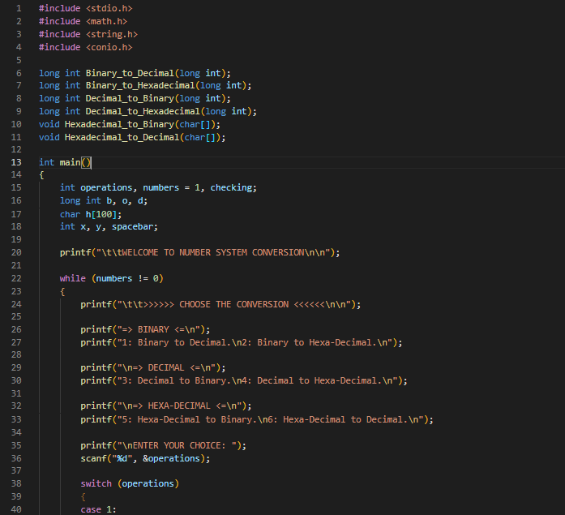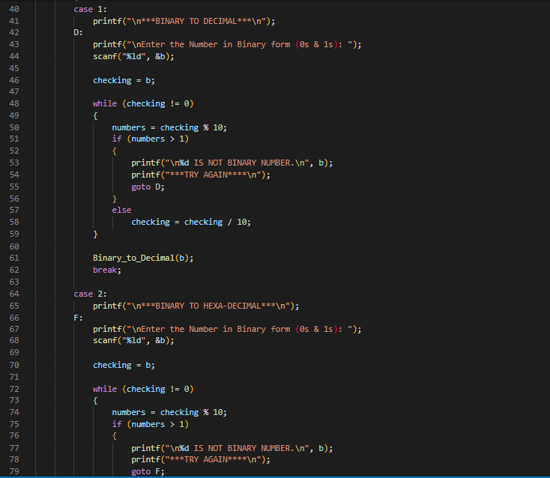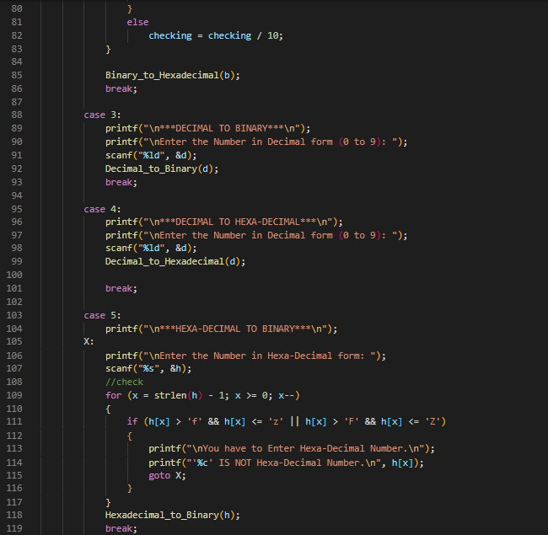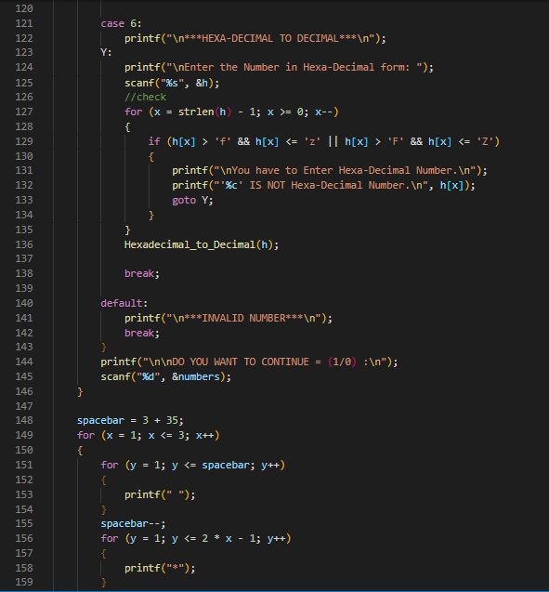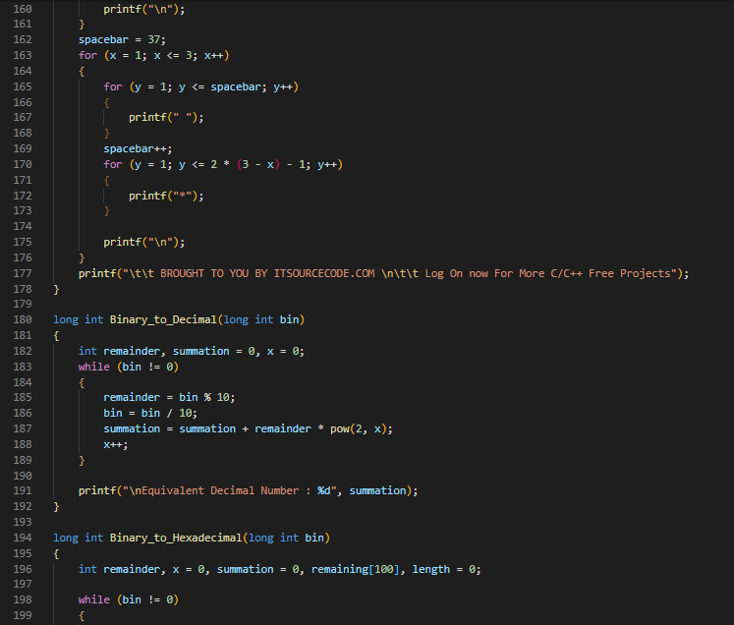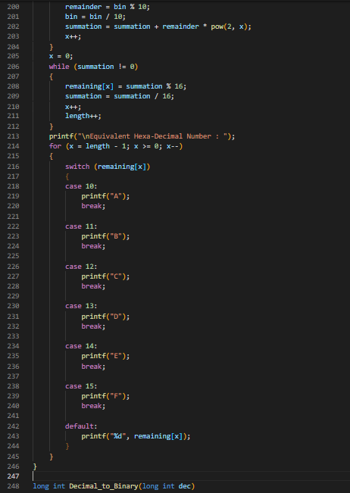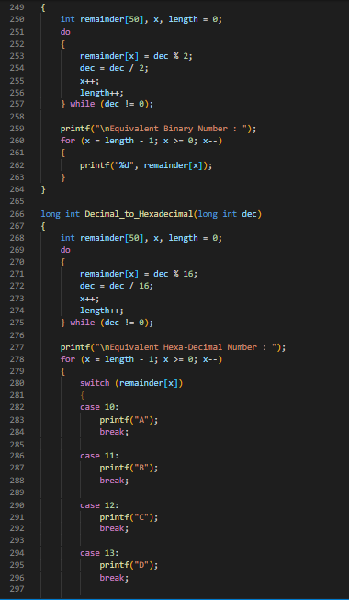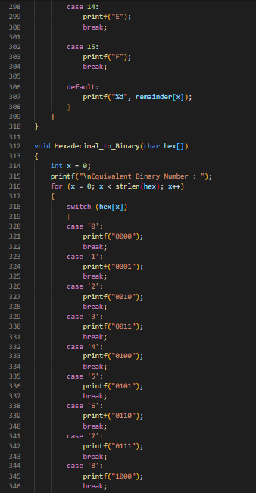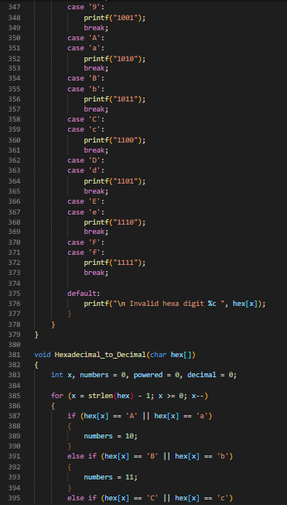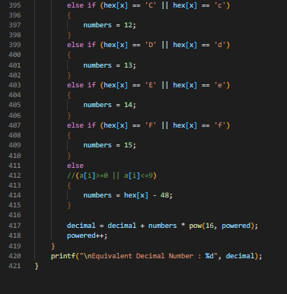

**Output:**

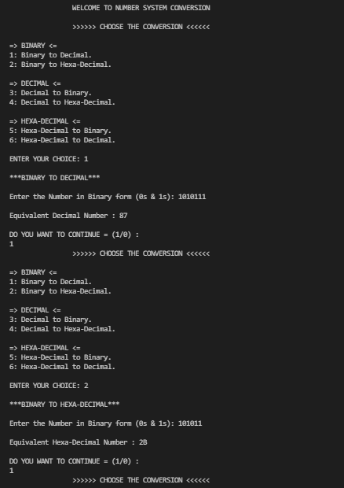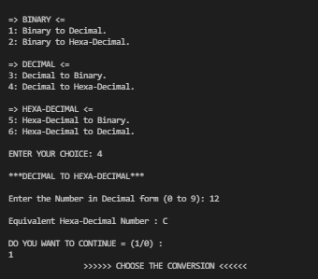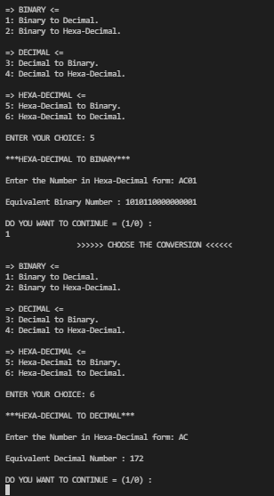

TASK 3

Adding, Deleting, Search and Display numbers

Description:

The topics we covered in this program is:

Control Structure,

If selection statement,

If else... selection statement,

switch Multiple selection statement,

while iteration Statement,

Counter Control iteration,

For iteration statement,

In this program we can add delete search and display items.

There is choice option for each.

If user Enter 0, it will quit program.

If user Enter 1, it will ask for number and add a number.

**Inserting An Element in An Array**

Inserting an element in an unsorted array is faster as compared to sorted array. This is because in an unsorted array, you do not have to worry about the new position of the element. The position of the new element is the last position in the array.

If user Enter 2, it will ask for number and delete a number.

**Deleting An Element from An Array**

To delete an element in an array, we need to first search the element. Then we need to delete the element and shift the rest of the elements to the left

If user Enter 3, it will ask for number and search a number.

**Searching an Element in an Array**

To search an element in an array you need to traverse through the array using loop and search for the given element.

If user Enter 4, it will display all numbers.

**Code**:

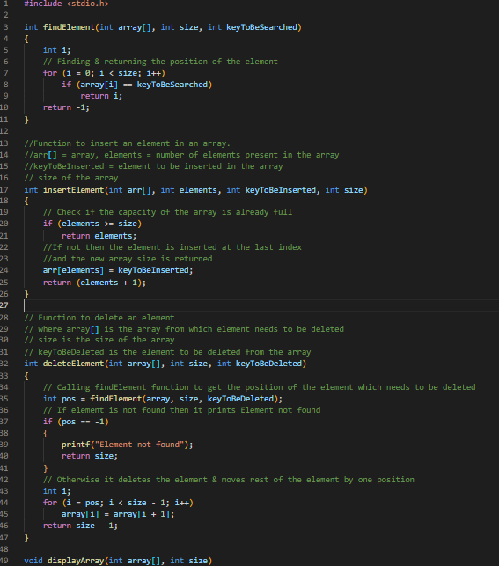

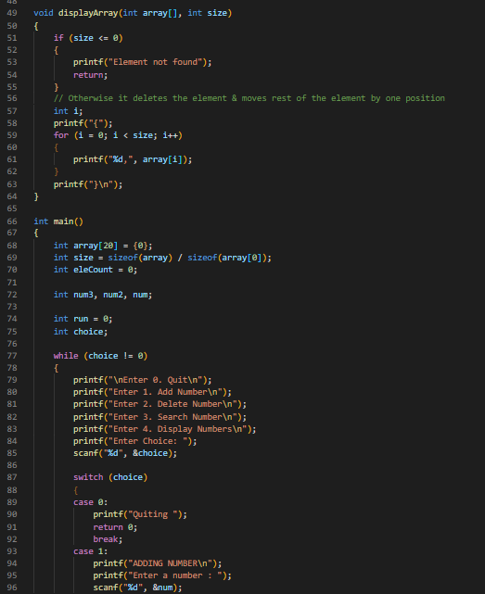

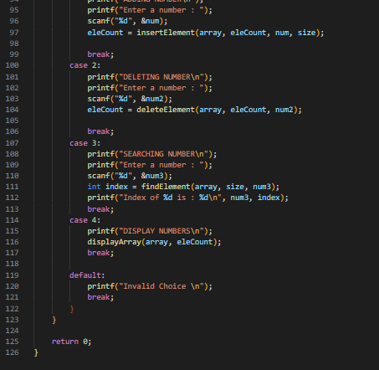

Output:

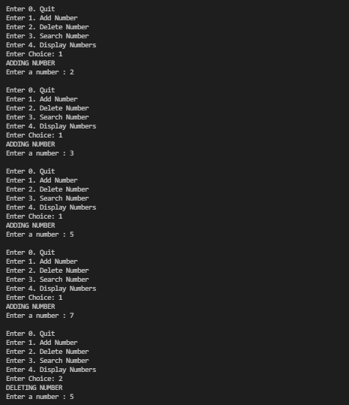

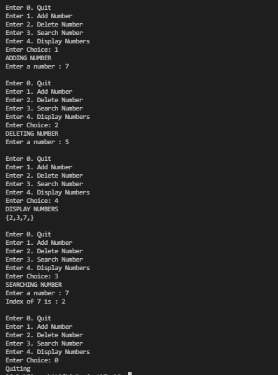

**Task4**

**Matrix**

Description:

The topics we covered in this program is:

Control Structure,

If selection statement,

If else... selection statement,

Counter Control iteration,

For iteration statement,

Arrays in C language

In this program 2D array is used,

As program starts it take input from user, it will fill matrix with entries,

void fillMAtrix (int arr[N][N])

it will fill the matrix

void displayMtrix (int arr[N][N]);

then it would display matrix on console.

bool isDiagonalMatrix(int mat[N][N]);

it will check whether matrix is diagonal or not and return true or false.

Matrix is diagonal if all the entries except diagonals are zero.

bool isScalarMatrix (int mat[N][N]);

it will check whether matrix is scalar or not and return true or false.

bool isUpperTriangularMatrix (int mat[N][N]);

it will check whether matrix is upper triangular or not and return true or false.

Matrix is upper triangular if all the entries of diagonal and upper entries of diagonal are non-zero.

bool check_lower_triangular_matrix (int mat[N][N]);

it will check whether matrix is lower triangular or not and return true or false.

Matrix is lower triangular if all the entries of diagonal and lower entries of diagonal are non-zero.

void transpose (int arr[N][N], int brr[N][N])

It will tale transpose of the matrix.

In transpose the entries in the rows change to columns and columns to rows respectively.

In this program we can add delete search and display items.

There is choice option for each.

If user Enter 0, it will quit program.

If user Enter 1, it will ask for number and add a number.

**Inserting An Element in An Array**

Inserting an element in an unsorted array is faster as compared to sorted array. This is because in an unsorted array, you do not have to worry about the new position of the element. The position of the new element is the last position in the array.

If user Enter 2, it will ask for number and delete a number.

**Deleting An Element from An Array**

To delete an element in an array, we need to first search the element. Then we need to delete the element and shift the rest of the elements to the left

If user Enter 3, it will ask for number and search a number.

**Searching an Element in an Array**

To search an element in an array you need to traverse through the array using loop and search for the given element.

If user Enter 4, it will display all numbers.

Code: 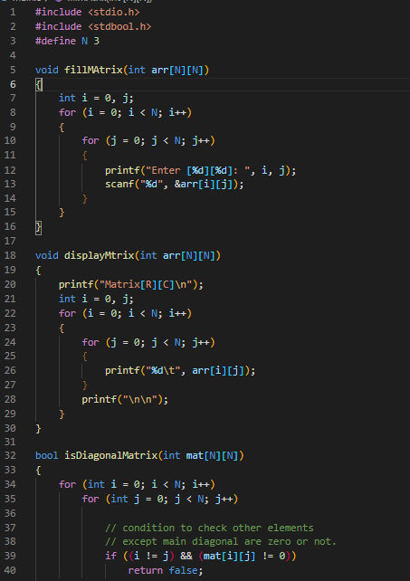

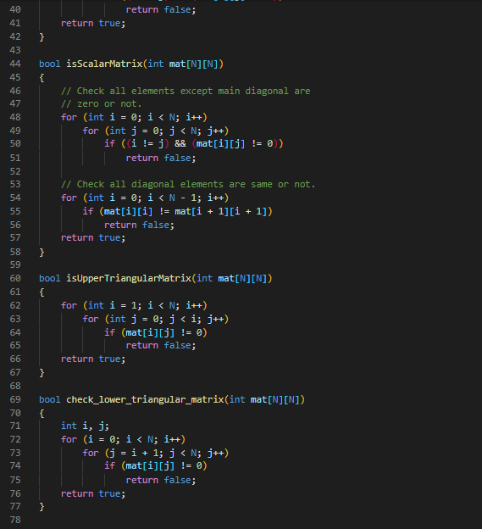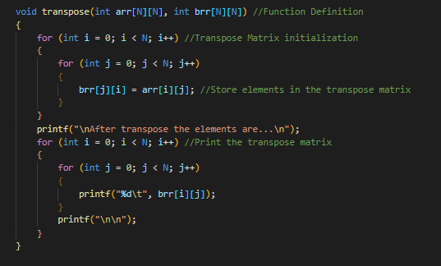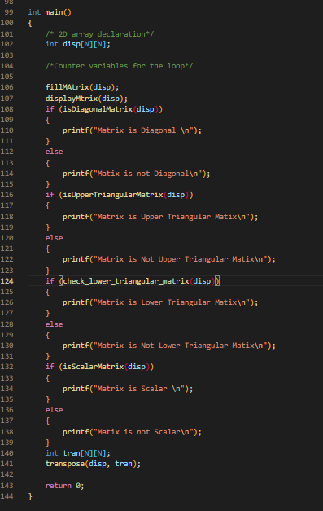

**OUTPUT:**

